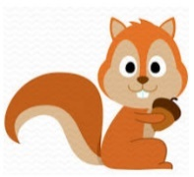
Squirrels Class
Optional Homework Projects

Here are some ideas for projects that you could do at home if you would like to. Bring each project in when you have done it so that you can show Mrs Botwright and Miss Feagan.

Explorers

If you were an explorer, what would you pack for your mission? Draw and label your suitcase.  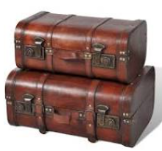 | Imagine you are an explorer who has discovered an uninhabited island. Build a den so that you have shelter from the weather. | 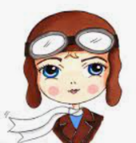  Amelia Earhart was the first woman to fly across the Atlantic. Find out three facts about her.
Edmund Hillary and Tenzing Norgay were the first people to summit Mount Everest. What can you find out about this mountain? | 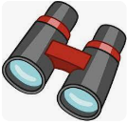  Become an explorer! What can you discover in your local area? Write about where you went and what you discovered. | Many parts of the Earth’s oceans are unexplored. Imagine that you discovered a new species of fish deep in the ocean. Name and write a report about your discovery.
  Would you like to be a space explorer? Build a rocket to take you up to space. | Explorers travel by land, sea and air. Design a vehicle for an explorer. You could draw this or make a 3D model. | Write a story about an explorer.  