The Learning Challenge

**Curriculum**

Key concept grid and vocabulary

**Great Explorers**



**Key concepts**

|  |  |  |
| --- | --- | --- |
| What is exploring? | Famous explorers | Maps and directions |
| Continents and oceans | Hot and cold countries | Being brave |
| Food and other discoveries | Exploring our surroundings | Kit and equipment |

**Key Vocabulary**

|  |  |  |  |  |  |
| --- | --- | --- | --- | --- | --- |
| Adventure | Left | Scotland | Map | Right | Turn |
| Northern Ireland | United kingdom | Wales | England | Forward | Backwards |
| Village | South Pole | North Pole | Features | Telescope | Beside |
| Location | Country | Town | City | Above | Under |
| Atlas | Globe | Equator | Explore | Great Britain | between |
| Expedition | Discover | Direction | Continents | Antarctica | Space |

|  |  |
| --- | --- |
| **Explorer** | A person who travels to unknown places |
| **Discover** | To find out about something |
| **Continent** | A very large area of land that is made of several countries. |
| **Ocean** | One of the very large areas of sea on the Earth’s surface |
| **Expedition** | A journey taken with a purpose |
| **Voyage** | A long journey on a ship or on a spacecraft |
| **Igloo** | Dome shaped shelter build from blocks of solid snow |
| **Blizzard** | A severe snow storm with high winds |
| **Iceberg** | A very large piece of ice that floats in the sea |
| **Icicle** | A long pointed stick of ice that is formed when drops of water freeze |
| **Temperature** | How hot or cold something is |



|  |
| --- |
| BBC - History - Scott of the Antarctic |
| **Robert Falcon Scott**  **1868 – 1912** |
| He led two expeditions to Antarctica. |
|  |
| **Helen Sharman**  **1963 - present** |
| The first British astronaut in space. |

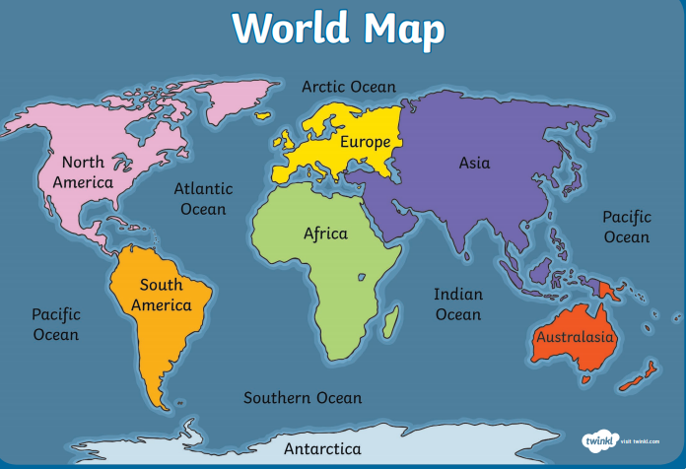

|  |  |  |  |  |  |
| --- | --- | --- | --- | --- | --- |
| Christopher Columbus Ships: Vessels that Discovered America (With ... | National Geographic Earth Explorer backpack M for DSLR/CSC |  |  |  |  |
| ship | rucksack | sledge | compass | map | binoculars |

**Useful tools**