**PTFA News**

Hi all.

A huge thanks for all the reading and for all the funds that you’ve raised as part of this year’s Readathon. We’ll know the final amount next week but as it stands we look to have raised over £1800 which is incredible. THANK YOU. The winning class and winners and runners up will be announced in the assembly Tuesday by the special guest - author Justin Coe. The winning class will receive £50 to spend on their class room for reading fun and the children that read the most in each class will be given their Waterstones vouchers. All those that participated in the online SuperKind fundraising will also receive a certificate.  We’ll be talking to the teaching team on how best to spend the money raised on reading lead activities.  We hope the children enjoy their author visit next week which was funded by the Readathon fundraising from last year.  Lastly thanks to the Helping Hands Team who helped count the stars Thursday!

We’ve now chosen - with the help of Mrs Stone - our logo for the PTFA. There were so many to choose from and it was such a super tricky task to select the winning design. Thanks to all the children that took part and a big congratulations to the winning designer  - Rupert from Hedgehogs. Congratulations Rupert, enjoy spending your Smyths voucher. We’ll be incorporating this design into our comms and all things PTFA soon. Rupert's winning design is attached.

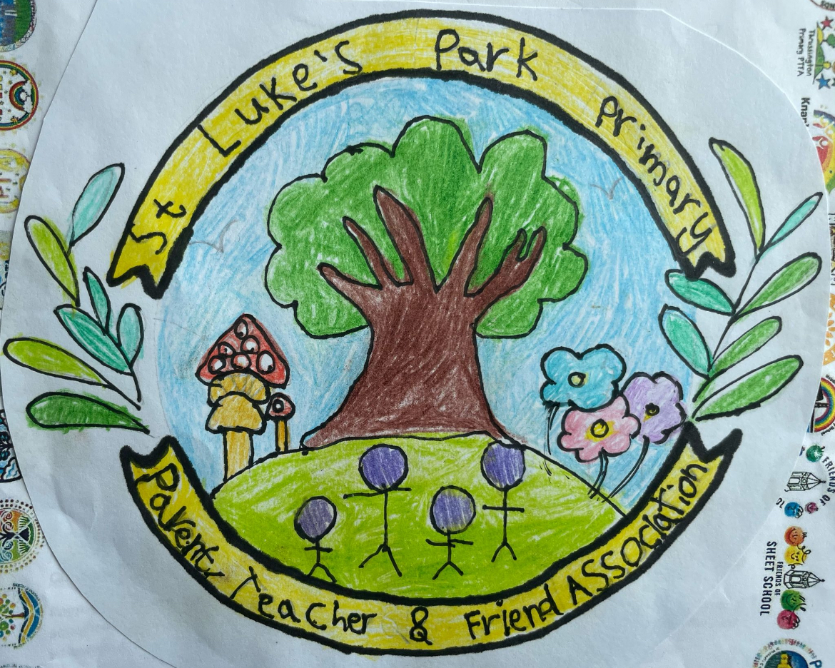

Join us for a night of fun at the Race Evening at Runwell Social Club on the 21 March. Currently ticket sales have been minimal. Full info and how to purchase tickets is attached. Please purchase your tickets in the next few days as we’ll have to review if this is going ahead next week.

We’ve some dates for your diaries coming up:

7 Mar Bingo Runwell Social Club 20:00 (Adults)

21 Mar Race Evening Runwell Social Club 19:00 (Adults)

25 Mar Wonder Woman Shop (in school event - children only)

4 Apr PTFA Easter Egg Hunt (in school event - children only)

4 Apr Bingo Runwell Social Club 20:00 (Adults)

16 May Adult Event - info to follow next week.

If you’ve any questions or suggestions for the PTFA team, get in touch at [stlukesparkptfa@gmail.com](mailto:stlukesparkptfa@gmail.com).

We’re also on Facebook - St Luke’s Park PTFA and Instagram st_lukes_park_ptfa

Thanks, Laura, Nicola, Liz, Claudia, Ashlee, Kayleigh, Melanie and Maria