
Squirrels Class – Spring Term
Optional Homework Projects

Here are some ideas for projects that you could do at home if you would like to. Bring each project in when you have done it so that you can show Mrs Botwright and Miss Feagan.

Castles, Knights & Dragons

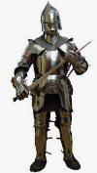  If you were a knight, what would your armour look like? Draw and label. | Visit a local castle (e.g. Hadleigh, Hedingham, Mountfitchet). Take lots of photos and find out all about the history of the castle. | Research medieval recipes. Can you create a medieval dish?  
Research a famous castle in the UK. Can you write some facts about it and draw a picture? | Design and create your own Coat of Arms that is special to you.  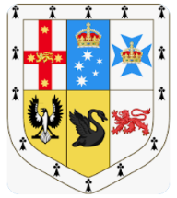 | Create a castle at home using any junk materials you can find. Can you add the features you have been learning about (e.g. drawbridge, turrets)?
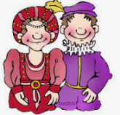  You are Lord or Lady of the Castle. Write a diary entry explaining what your typical day is like. | Become a knight planning to invade a castle. Draw a map to show how you will sneak in and take over the castle. | Write a story about dragon.  

