The Learning Challenge

**Curriculum**

Key concept grid and vocabulary

**Castles, Knights & Dragons**

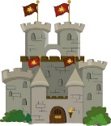

**Key Concepts**

**Castles, Knights & Dragons**

|  |  |  |
| --- | --- | --- |
| What is a castle? | Defending a castle | Castle facts |
| Parts of a castle | Who lived in a castle? | Famous castles in the UK |
| Why did knights wear armour? | Rich and poor | Jobs and pastimes (knights and lords) |

**Key Vocabulary**

|  |  |  |  |  |  |
| --- | --- | --- | --- | --- | --- |
| King | attack | flag | helmet | knight | wood |
| tower | gate | window | Queen | beast | brick |
| defence | medieval | sword | dragon | shield | metal |
| royal | moat | enemies | drawbridge | arrow-loops | armour |
| armory | dungeon | battlements | portcullis | succession | drawbridge |
| Sir | look out | turret | coat of arms | barbican | bailey |
| invasion | ruins |  |  |  |  |

|  |  |
| --- | --- |
| **Castle** | A large strong building, built in the past to protect the people inside from attack |
| **King** | Male ruler of a country |
| **Queen** | Female ruler of a country |
| **Lord and Lady** | Important people who run and own castles |
| **Monarch** | A monarch, such as a king or queen, rules a kingdom or empire. |
| **Knight** | A soldier in armour on a horse |
| **Servants** | People who did everyday jobs around the castle (cooking, cleaning, spinning) |
| **Armour** | A special suit made from metal that knights wore to protect themselves |
| **Ruins** | The remains of a building that have been damaged or weakened |



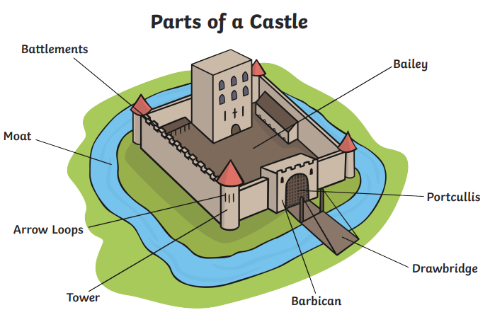

**Queen Elizabeth II** was the longest-reigning monarch in British history. She had been Queen for 70 years.

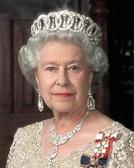

|  |  |  |  |
| --- | --- | --- | --- |
| Windsor Castle, Palace of Holyroodhouse halt ticket sales ... | Dunluce Castle Medieval Irish Castle on the Antrim Coast, Bushmills | Edinburgh Expert Walking Tours - Blog | Cardiff Castle |
| **Windsor Castle**  England  England Flag 3ft x 2ft Medium - 100% Polyester - Metal Eyelets ... | **Dunluce Castle**  Northern Ireland  St Patricks Cross Flag | Buy St Patricks Cross Flags at Flag and ... | **Edinburgh Castle**  Scotland | **Cardiff Castle**  Wales |