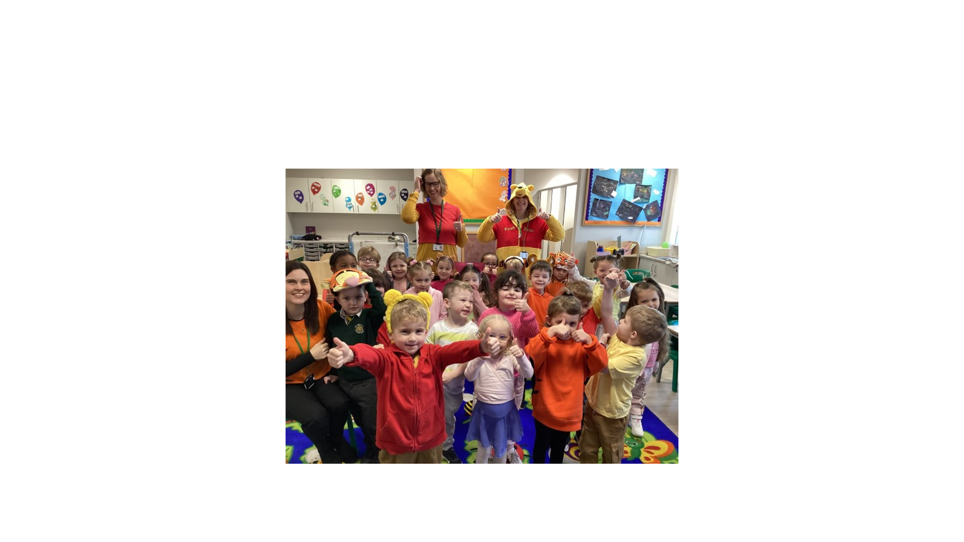

World Book Day

The children in Little Owls dressed up as a character from Winnie The Pooh. We heard lots of stories from the One hundred acre wood, played guess the character, identify the odd one out (Winnie the pooh dressed for night time), describe Pooh wearing different costumes)

We also made biscuits and honey sandwiches.