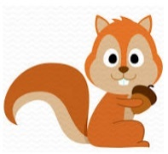
Squirrels Class
Optional Homework Projects

Here are some ideas for projects that you could do at home if you would like to. Bring each project in when you have done it so that you can show Mrs Botwright and Miss Feagan.

Africa

  If you were travelling to Africa, where would you go and what would you pack in your suitcase? What type of clothes would you need for the weather? | Draw a picture of  The Big Five  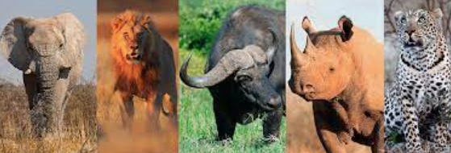 |   Look up a simple African recipe to try out at home.
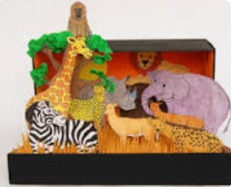  Create a safari habitat scene using a shoebox and any resources you can find. | Research traditional African music – can you create your own dance to match the beat of the music? | Imagine you have been on an African safari. Write a diary entry describing which animals you saw and how you felt.
Make a postcard from Africa telling your friends where you have explored and what you have seen. | Create an African inspired pasta necklace using painted uncooked pasta in repeating patterns.  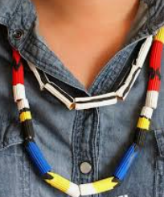 | 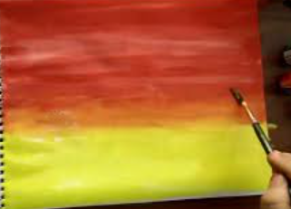  Make a beautiful African sunset picture using paints, watercolours, pastels or crayons.

