**Key concepts**

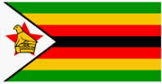

Out of Africa

|  |  |  |
| --- | --- | --- |
| Location  (Africa) | Animals and their habitats | African art  (patterns and prints) |
| Main features of  Africa  Savannah landscape, mountains, volcanoes | Culture and tradition  (tribal dancing) | African homes |
| How people live in Africa - food, clothes, jobs | Who is Nelson Mandela? | Hot and cold countries |

|  |  |
| --- | --- |
| **Savannah** | A grassy plain in tropical and subtropical regions, with few trees |
| **Habitat** | The natural home or environment of an animal or plant. |
| **Safari** | An expedition to observe animals in their natural habitat. |
| **Prey** | Animals that are hunted for food by other animals |
| **Predator** | Animals that eat other animals |
| **Herbivore** | An animal that only eats plants |
| **Carnivore** | An animal that only eats other animals or insects |
| **Omnivore** | An animal that eats both plants and other animals or insects |
| **Equator** | The **equator** is an imaginary line around the middle of the planet. The closer you are, the warmer it is. |
| **Human feature** | Something that has been put on the Earth by a human– it has been built. |
| **Physical feature** | Something that is put there because of nature– it is natural. |

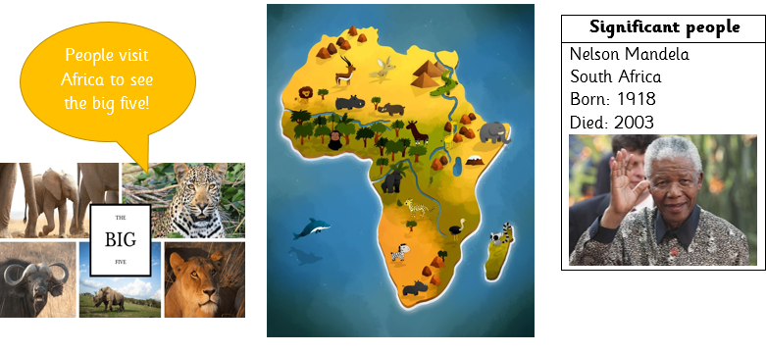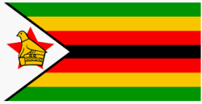

**Facts about Zimbabwe**

|  |  |  |
| --- | --- | --- |
| Six Million Years of African Savanna | NSF - National Science ... | Wet Season - Zimbabwe |  |
| Zimbabwe is mostly a savannah rich in wildlife in Southern Africa. | Zimbabwe has a tropical climate. Almost no rain between April-October and a rainy season from November – March. | Victoria Falls is in Zimbabwe. It is home to a ‘Moonbow’, which is a rainbow at night. It is o**ne of the Seven Natural Wonders of the World.** |